* **Title Page: cs 1011-051 – Lab 3 <*CalculateTaxes*>**
* <Denise Malisa>
* <28/09/2020>
* <Page Break>
* **I. Objectives**

The objective of this code is to calculate taxes for a filer. The program is supposed to ask the filer for their status as well as their income earned in 2019 and then output the estimated taxes

and they will be required to pay by April 15, 2020.

**II. Requirements**

The program is supposed to calculate the taxes for a flier based on their status and their income. The program asks the user, firstly, whether they are a single or joint filer. Secondly, for their estimated income for the year of 2019.Finally, based on the filer’s status, the program will calculate the estimated tax and the effective tax rate. The income earned will determine the way and rates used to calculate their tax. Also, the estimated tax and the effective tax rate are supposed to be to two decimal places so I used Decimal Format for.

* **III. Design:**

Input status

Input incomeEarned

If status == ‘s’

If incomeEarned is within a certain tax bracket

Calculate the taxOwed by multiplying the rates of the specific tax bracket the filers income fits into.

Calculate the effectiveTaxRate

If status == ‘j’

If incomeEarned is within a certain tax bracket

Calculate the taxOwed by multiplying the rates of the specific tax bracket the filers income fits into.

Calculate the effectiveTaxRate

Output message for effective tax rate and taxes owed

* **III. Test Plan/Test Strategy**

I will check to see that the program outputs the correct values for the single filer by entering the value $ 66,480 and seeing that it outputs the correct result.

Secondly, I will check to see that the program outputs the correct values for the married filer by entering the value $ 367,640 and seeing that it outputs the correct result. Also checking that the output, the produces what it is supposed to i.e. estimated taxes and effective tax rate and also that it obtains the user input.

* **V. Results**

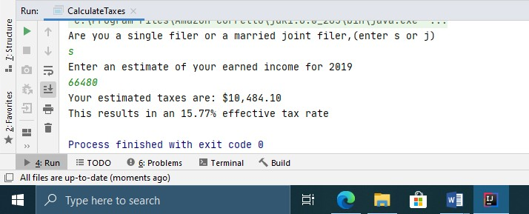

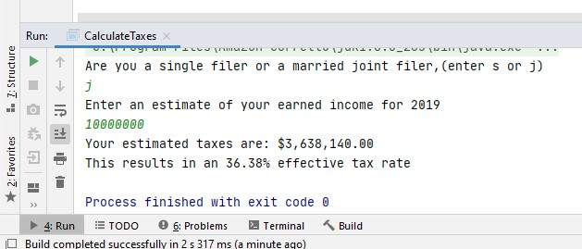

* **V. Discussion**

I learnt how to implement conditionals in java. Also, how to use Decimal Format to get the program to display the number of decimal points required for the program.